**Report No : 1**

**Report Name: Write a program to in inseration an array**

**Code:**

#include <iostream>

using namespace std;

int main(){

int n , i;

cout << "Enter Array Size: ";

cin >> n;

int myArray[n];

for (i = 0; i < n; i++){

cout << "Enter " << (i + 1) << " element: ";

cin >> myArray[i];

}

cout << "Old Array: ";

for (i = 0; i < n; i++){

cout << " " << myArray[i];

}

int j = n, k;

cout << "\nEnter Insert index in array: ";

cin >> k;

while (j >= k) {

myArray[j + 1] = myArray[j];

j -= 1;

}

int item;

cout << "Enter insert value: ";

cin >> item;

myArray[k] = item;

n = n + 1;

cout << "Updated Array: ";

for (i = 0; i < n; i++){

cout << " " << myArray[i];

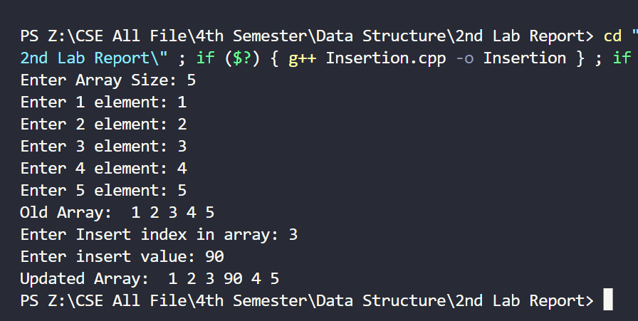 }

}

**Report No : 2**

**Report Name: Write a program to in deletion an array**

**Code:**

#include <iostream>

using namespace std;

int main(){

int n , i;

cout << "Enter Array Size: ";

cin >> n;

int myArray[n];

for (i = 0; i < n; i++){

cout << "Enter " << (i + 1) << " element: ";

cin >> myArray[i];

}

cout << "Old Array: ";

for (i = 0; i < n; i++){

cout << " " << myArray[i];

}

int k;

cout << "\nEnter deletion index in array: ";

cin >> k;

int item = myArray[k];

for (int j = k; j < n; j++){

myArray[j] = myArray[j + 1];

}

n = n - 1;

cout << "Updated Array: ";

for (i = 0; i < n; i++)

{

cout << " " << myArray[i];

}

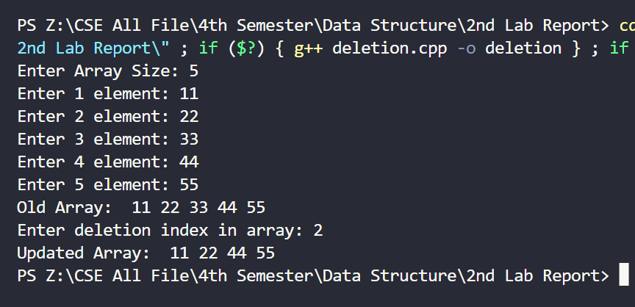}

**Report No : 3**

**Report Name: Write a program to in binary search an array**

**Code:**

#include <bits/stdc++.h>

using namespace std;

int main(){

int n , i;

cout << "Enter size of array: ";

cin >> n;

int myArray[n];

for(i = 0 ; i < n ; i++){

cout << "Enter " << (i + 1) << " element: ";

cin >> myArray[i];

}

int s = sizeof(myArray) / sizeof(myArray[0]);

sort(myArray, myArray + s);

int search;

cout << "\nEnter element to search: ";

cin >> search;

int loc = 0 , beg = 0 , end = n-1;

int mid = (beg + end)/2;

while(beg <= end){

if(myArray[mid] == search){

loc = mid;

cout << "index: " << loc << " Search Value: " << search;

break;

}else if(search < myArray[mid]){

end = mid - 1;

}else if(search > myArray[mid]){

beg = mid + 1;

}

mid = (beg + end)/2

}

if(loc == 0){

cout << "Result not found";

}

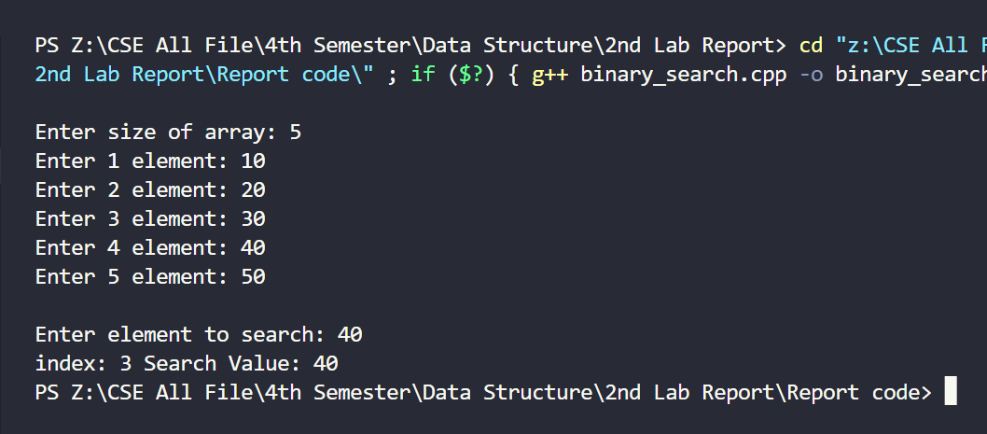}

**Report No : 4**

**Report Name: Write a program to in linear search an array**

**Code:**

#include <iostream>

using namespace std;

int main(){

int n;

cout << "Enter size of array: ";

cin >> n;

int myArray[n];

int i;

for(i = 0 ; i < n ; i++){

cout << "Enter " << (i + 1) << " element: ";

cin >> myArray[i];

}

int search;

int find = 0;

cout << "\nEnter element to search: ";

cin >> search;

for(i = 0 ; i < n ; i++){

if(myArray[i] == search){

find = 1;

break;

}

}

if(find == 1){

cout << "\nResult found in index: " << i << " and number is: " << search;

}

else{

cout << "\nResult not found";

}

return 0;

